2012 H1 Math (8864) JC 2 Preliminary Exam Paper 1 – Marking Scheme

Question 1

Find the range of values of p for which the equations 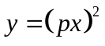and 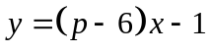 have real solutions. [4]

Qn | Solution
1 | Quadratic Equations + inequality (include condition for real roots)
-------------- (1)
----------- (2)

(1) = (2) 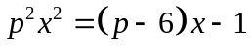
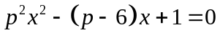

For real solutions, 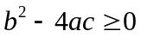
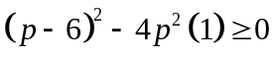
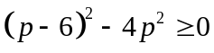
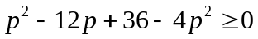
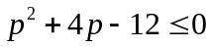
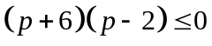
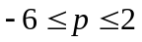

Question 2

Find
(a) 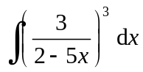 , [3]
(b) 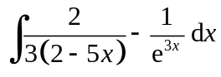. [3]

Qn | Solution
 | Integration Techniques
(a) | 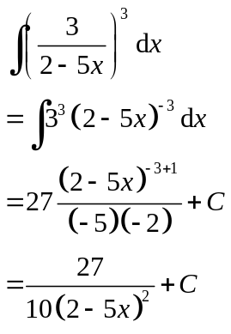
(b) | 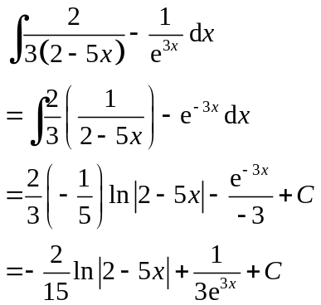

Question 3

The diagram shows a rectangle ABCD inscribed in a semicircle with centre O and radius 5 cm. Given that AB is x cm, show that the perimeter L cm of the rectangle ABCD can be expressed as 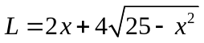.
Using differentiation, find the exact value of x when L is maximum. [6]

A
B
D
C
x

O

Qn | Solution
3 | Application of Differentiation (Max/Min Problem)
(i) | By Pythagoras’ Theorem, 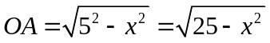  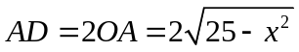  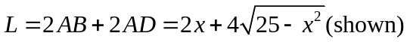  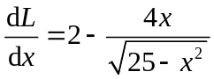  At stationary point,  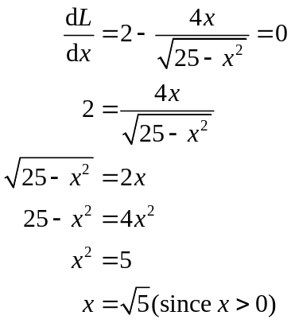  L is maximum when 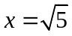.
  x | 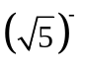 |  | 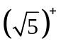
  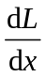

Question 4
The curve C₁ has equation 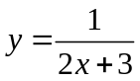. The curve C₂ has equation 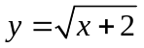.
(i) Sketch C₁ and C₂ on the same diagram, showing clearly the intersection(s) with the axes and the equation(s) of the asymptote. [4]
(ii) State the solution to the equation 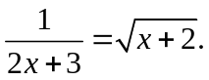 [1]
(iii) Find the exact area bounded by C₁, C₂ and the y-axis. [4]

Qn | Solution
4 | Curve Sketching & Integration
(i) | 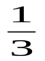  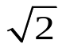  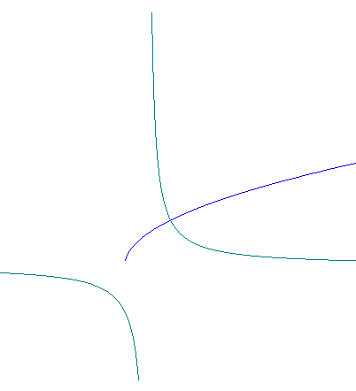  y = 0  x  y  –2  C₂  C₁
(ii) | From the GC, x = 1 is the solution.
(iii) | 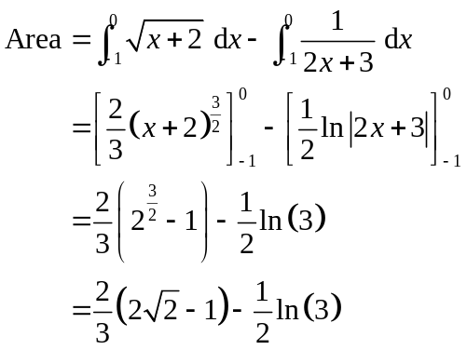

Question 5

A curve C has the equation 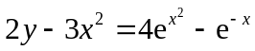.
(i) Show that 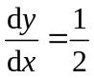 at . [4]
(ii) Hence find the equations of the tangent and normal at . [3]
(iii) The tangent and normal at meet the x-axis at P and Q respectively. By finding the coordinates of P and Q, find the length of PQ. [3]

Qn | Solution
5 | Techniques & Applications of Differentiation (Expo, Tan/Norm)
(i) | 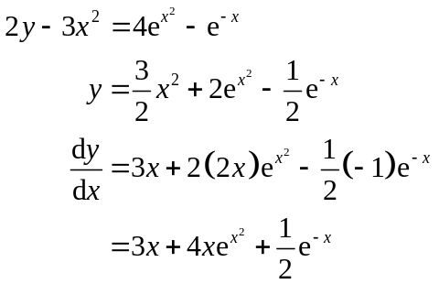  Therefore at ,  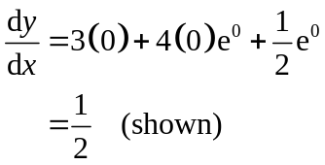
(ii) | At ,  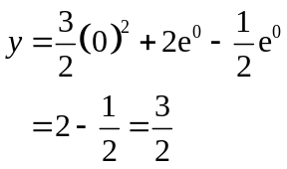  Hence the equation of the tangent is  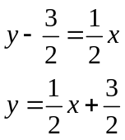  and the equation of the normal is  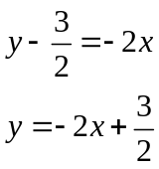
(iii) | When 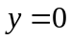,  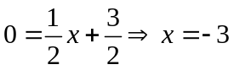  Coordinates of P are 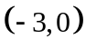.  When ,  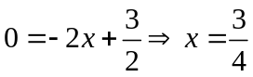  Coordinates of Q are 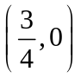.  Therefore, the length of PQ 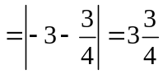 units.  Alternatively,  the length of PQ 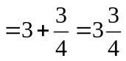 units.

Section B
Question 6

A particular school has 8 departments and a total of 300 staff. The number of staff in each department is different. The principal decides to survey a sample of 50 staff to seek their opinions on the school’s staff welfare. Simple random sampling and stratified sampling are suggested on how the sample can be selected.

- Describe how each method can be carried out. [4]
(ii) Give a possible reason why stratified sampling is preferred over simple random sampling. [1]

Qn | Solution
6 | Sampling methods
(i) | Method 1: Simple random sampling  Each staff in the school is assigned a number from 1 to 300. Use a computer or GC to generate 50 random numbers. The staff corresponding to the 50 numbers is then selected to make up the sample of 50 staff.  Method 2: Stratified sampling  The sample of 50 staff is made up of staff from all 8 departments. The staff  are selected at random (using simple random sampling or systematic  sampling) from each department, with the number selected being  proportional to the number of staff in the department.
(ii) | Stratified sampling ensures that all departments are fairly represented while Simple random sampling may not.

Question 7

John plays a computer game which has 3 stages to be completed. He can only win or lose in each stage. From his past experience in playing the game, it is known that the probability of him winning in Stage 1 is 0.7. However, the probability of him winning the next 2 stages depends on the result of the preceding stage. The observation is as follows.

- The probability of him winning the next stage, given that he won the previous stage, is 0.8.
- The probability of him winning the next stage, given that he lost the previous stage, is 0.4.

One point is awarded for winning in a stage and one point is deducted for losing in a stage. To win the game, the total score must be positive.

Construct a probability tree diagram showing this information. [2]

Find

- the probability that he will attain a positive total score in a game, [2]

(ii) the probability that he will attain a negative total score in that game, given that he lost in Stage 1. [2]
Qn | Solution
7 | Probability – Tree Diagram
(i) | lose  win  win  0.6  0.4  0.2  0.8  0.6  0.4  0.2  0.8  0.6  0.4  0.2  0.8  0.3  0.7  win  win  win  win  win  lose  lose  lose  lose  lose  lose  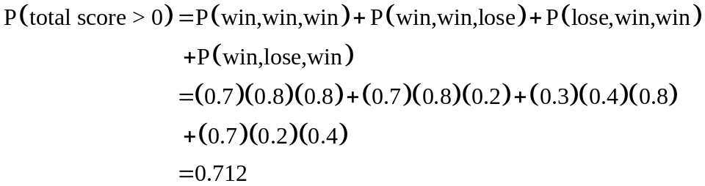
(ii) | 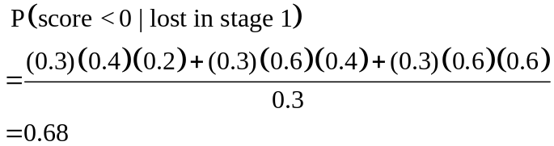  Alternatively,  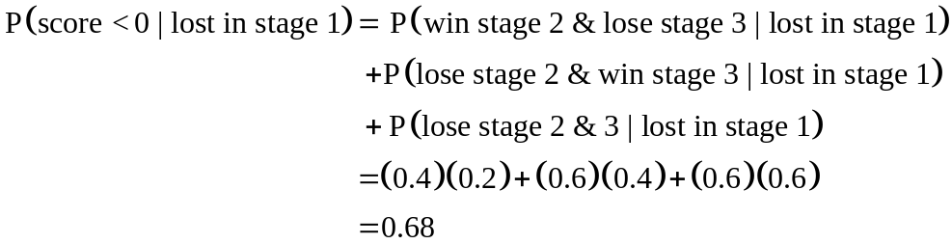  Alternatively,  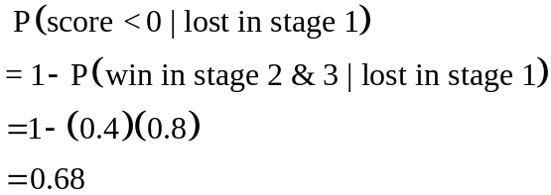

Question 8

The events A and B are independent. It is given that 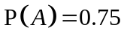and 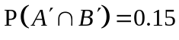. Find
- 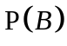, [3]
- 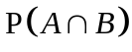. [1]
The events B and C are mutually exclusive such that 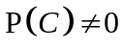. Given that C is a subset of A, find the range of possible values of 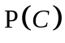. [2]
Qn8 | Solution
 | Probability
(i) | 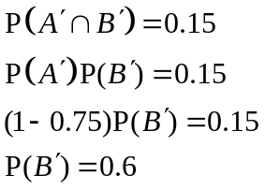  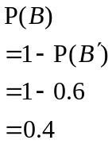  Alternatively,  Given ,  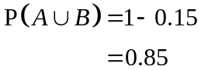  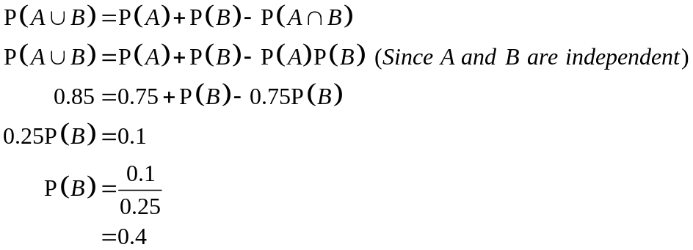
(ii) | 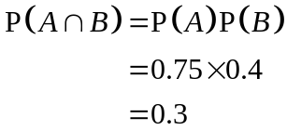
(iii) | Since C is a subset of A,  B  A  0.15  0.3  0.1  0.45  and C and B are mutually exclusive,  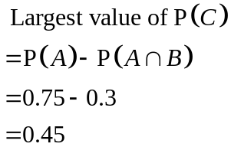  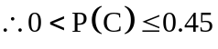
Question 9

Packets of a particular brand of orange juice are said to contain 300 ml each. A random sample of 100 packets is taken and the volume of liquid in each packet is measured. The volumes, x ml, are summarised by 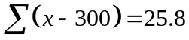 and 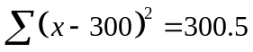.

- Find unbiased estimates of the population mean and variance. [3]
(ii) Test, at the 7% significance level, whether the population mean volume differs from 300ml.
[4]
(iii) Explain, in the context of the question, the meaning of ‘at the 7% significance level’. [1]
(iv) Without carrying out further tests, explain whether the conclusion remains unchanged if the test had been for an increase in the mean at the 7% significance level. [2]

Qn | Solution
9 | Hypothesis Testing
(i) | - Let X be the volume of orange juice in a packet (in ml).  Let denotes the population mean volume of orange juice in a packet.  Unbiased estimate for is 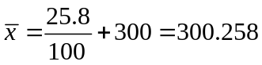  Unbiased estimate for 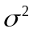 is 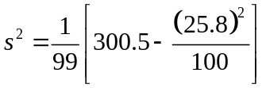  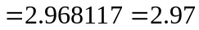 (3 s.f)
(ii) | H₀: 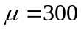  H₁: 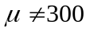  Since n=100 is large, by Central Limit Theorem, 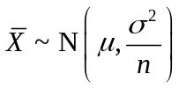 approximately.  Test Statistic: 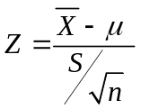  Level of significance: 7%  Reject H₀ if 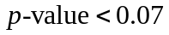  Assuming H₀ is true,  From GC, 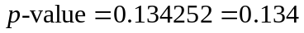(3 s.f.)  Since 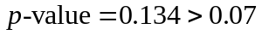, we do not reject H₀ and conclude that there is insufficient evidence, at 7% level of significance, that the population mean volume differs from 300ml.
(iii) | There is a probability of 0.07 of concluding that the volume of orange juice in a packet differs from 300ml when in fact it is 300ml.
(iv) | H₀:  H₁: 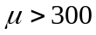  For a right-tail test,  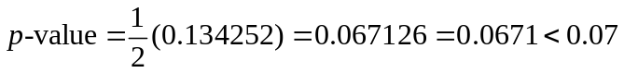  Hence, we reject H₀ at and conclude that there is sufficient evidence, at 7% level of significance, that the population mean volume is more than 300ml. Hence the conclusion does not remain unchanged.

Question 10
A large number of tickets are sold in a lottery. Each ticket can either win $5 or nothing. Each ticket has a constant probability of p of winning $5 and Charlie bought 45 tickets.
- State an assumption needed for the number of winning tickets bought by Charlie to be well modelled by a binomial distribution. [1]
- Given that the probability that Charlie has less than one winning ticket is 0.003, state an equation in terms of p and show that p = 0.121 (correct to 3 significant figures). [3]
(iii) Find the probability that Charlie wins at most $25. [2]
(iv) Use a suitable approximation to find the probability that Charlie has more than 8 winning tickets. [4]

Qn | Solution
10 | Binomial distribution
 | Outcome of each ticket is independent of one another
(ii) | Let X be the number of winning tickets out of 45  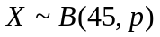  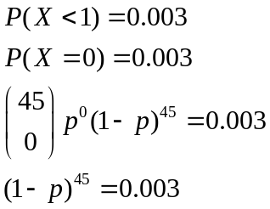  Using GC, 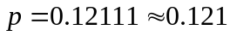
(iii) | 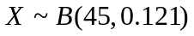  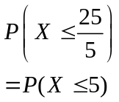  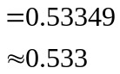
(iv) | Since n = 45 is large, np =5.445 > 5 and nq =39.555 > 5  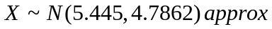  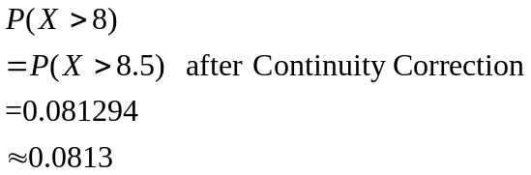

Question 11
Lean Manufacturing Pte Ltd specializes in the production of microchips. The raw materials make up 15% of its total production cost for making microchips. Depending on the production quantity (q) required by the client, the total production cost ($C) are shown in the table below.

q | 100 | 200 | 300 | 400 | 500 | 600 | 700 | 800
C | 20 | 38 | 54 | 68 | 120 | 90 | 98 | 104

(i) Calculate the linear product moment correlation coefficient between q and C, and comment on the value found. [2]

(ii) Sketch the scatter diagram for the data. [2]

(iii) One of the pairs of data appears to be recorded wrongly. Indicate the corresponding point on your diagram by labeling it P, and explain why the scatter diagram for the remaining points may be consistent with a linear model. [2]

(iv) Omitting P, calculate the equation of a suitable least squares regression line, justifying the choice of the regression line. [2]

(v) Use the regression line found in part (iv), estimate the production quantity required by the client when the cost of the raw materials is $15. Comment on the reliability of the estimate. [3]

Qn | Solution
11 | Correlation and Regression (include raw data)
(i) | Using GC, r = 0.877  There is a positive linear relationship between q and C.  C
(ii)  (iii) | P  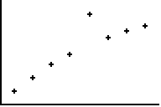  120  20  100  800  q  Since the rest of the points lie close to a straight line, the linear model is appropriate.
(iv) | Using GC,  C = 14.589 + 0.11932q  C = 14.6 + 0.119q (3 s.f.)  Since q is the independent variable and C is dependent on q, the regression line of C on q is selected.
(v) | When cost of raw materials = $15,  total production cost C = $100,  100 = 14.589 + 0.11932 q  q = 715.81  q = 716 (3 s.f.)  Since r = 0.988 is close to 1 and C = 100 is within data range, the estimate is reliable.

Question 12

The mass of a papaya harvested in Plantation A is found to have mean 1.5 kg and standard deviation 0.15 kg. The mass of a papaya harvested in Plantation B is found to have mean 1.2 kg and standard deviation 0.2 kg. The masses of papayas from both plantations are independent. Papayas in both Plantations A and B are packed separately into baskets of 50 each.

(i) Find the probability that the difference between the mean mass of a papaya in a randomly chosen basket from Plantation A and the mean mass of a papaya in a randomly chosen basket from Plantation B is less than 0.2kg. [4]

(ii) Find the probability that a randomly chosen basket from Plantation A weighs less than 74 kg and a randomly chosen basket from Plantation B weighs more than 62 kg. [4]

(iii) The baskets of papayas from Plantation A and B are sold at $0.30 per kg and $0.40 per kg respectively. Find the probability that a randomly chosen basket from Plantation B is sold for a higher price than a randomly chosen basket from Plantation A. [4]

Qn | Solution
12 | Normal distribution + Sampling + CLT
(i) | Let A denote the mass of a papaya from Plantation A (in kg).  Let B denote the mass of a papaya from Plantation B (in kg).  By Central Limit Theorem, since n=50 is large,  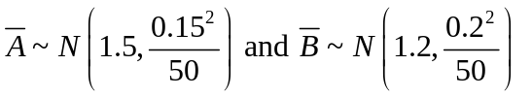 .  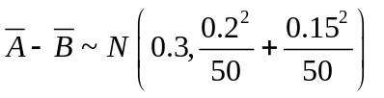  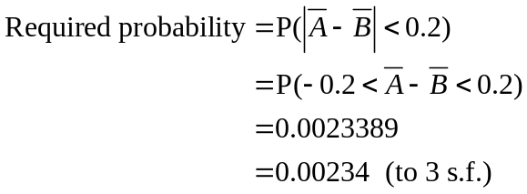
(i) | Let X denote the mass of a basket of 50 corns from Plantation A (in kg).  Let Y denote the mass of a basket of 50 corns from Plantation B (in kg).  By Central Limit Theorem, since n=50 is large, 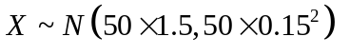and 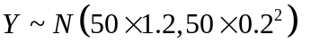.  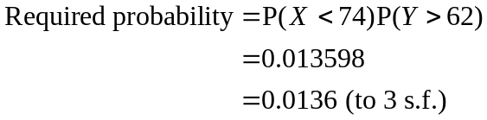
(ii) |   